EXPERIMENT 16 —HIGH LEVEL PROGRAMMING EXTENSIONS – PROCEDURES
AIM
To implement procedures using program in MySQL.

Create a simple procedure
This is equivalent to the manual's first procedure problem: a procedure that gets all records from a table

DELIMITER $$

CREATE PROCEDURE get_juice_records()
BEGIN
SELECT * FROM juiceshopc;
END $$

DELIMITER ;

Execute the procedure
The manual uses CALL procedure_name(); to execute a stored procedure.
Run:
CALL get_juice_records();
You should get all records from juiceshopc.
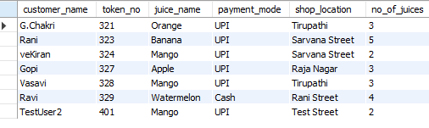

Create a second procedure with a parameter
We will make a procedure that accepts a token number and displays that customer's details.
DELIMITER $$

CREATE PROCEDURE get_customer(IN p_token INT)
BEGIN
SELECT *
FROM juiceshopc
WHERE token_no = p_token;
END $$

DELIMITER ;

Call the second procedure
Run:
CALL get_customer(321);
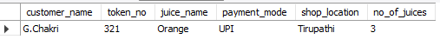
Try another customer
CALL get_customer(323);

RESULT
Thus the stored procedures were created and executed successfully using MySQL.

